BLOCK CHAIN ENGINEERING
ASSIGNMENT-5
A.Akanskha
2303A53004
Batch-46
To develop and perform unit testing of smart contracts using
the Truffle framework
.
Objective
To implement a Personal Portfolio Smart Contract that stores and retrieves user profile data and verify its functionality using unit testing.
Requirements
• Node.js
• Truffle
• Ganache
• Visual Studio Code
Procedure
1. Install required software.
2. Create a new Truffle project.
3. Write the Solidity smart contract (PersonalPortfolio.sol).
4. Configure Ganache network.
5. Compile the contract using truffle compile.
6. Deploy using truffle migrate.
7. Write unit test file in test folder.
8. Run truffle test to verify functionality.
Result
The smart contract was successfully deployed and unit tested using the Truffle framework.

Code:

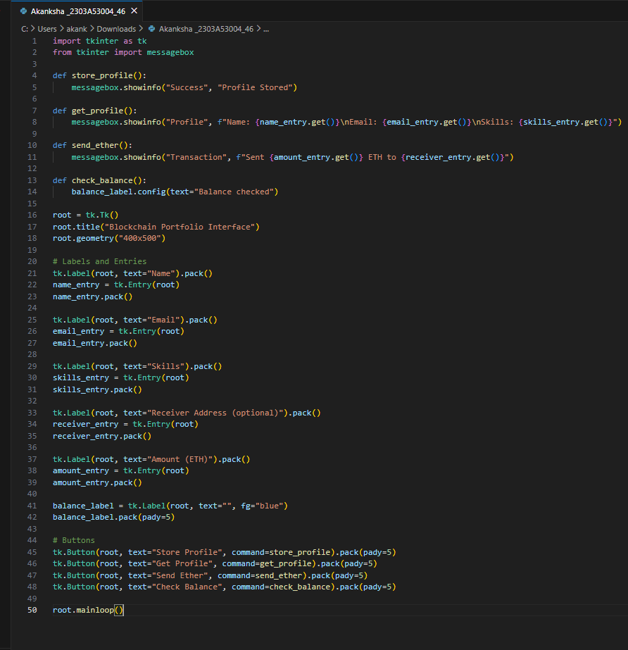

Output:
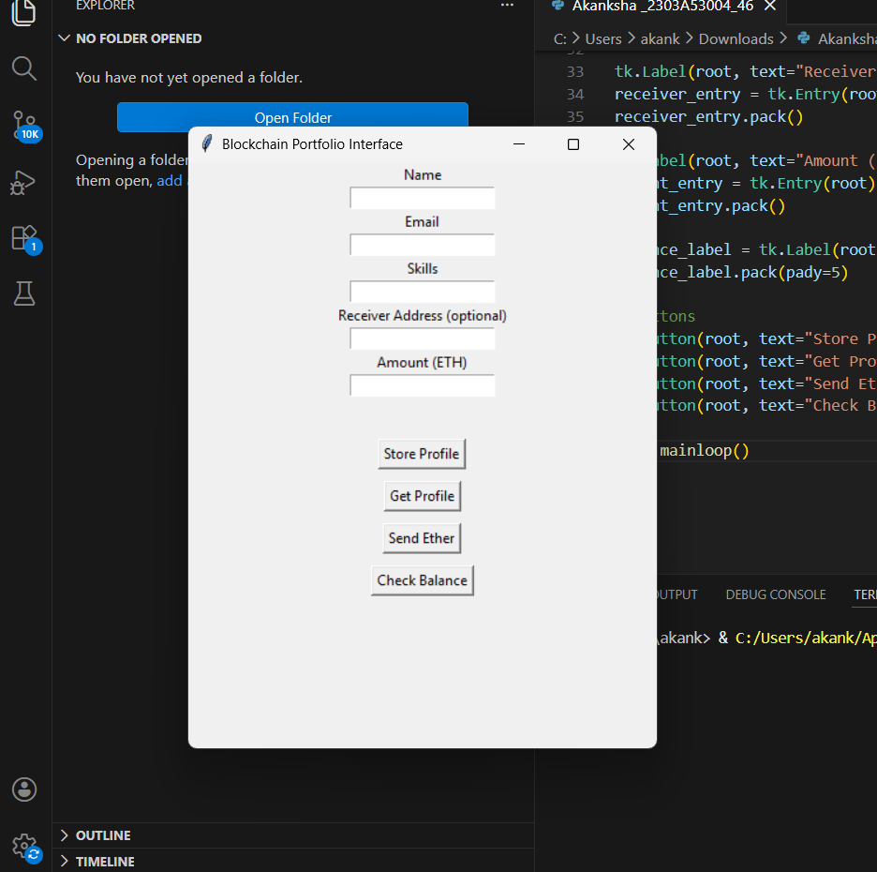
Conclusion
The Blockchain Portfolio application was successfully developed and connected to the local blockchain. All functions worked correctly, confirming proper smart contract and GUI integration

